PERTH MODERN SCHOOL

DIGITAL TECHNOLOGIES

TASK **4**: Website

|  |  |
| --- | --- |
| **Assessment type:** | Production |
| **Unit focus:** | Web Technologies |
| **Task duration:** | 4 weeks |
| **Task weighting:** | **30%** |

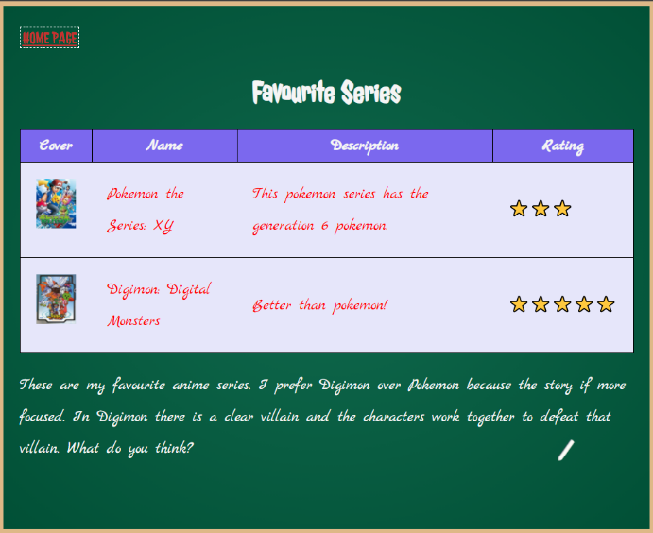**Task 4: Website**  
Web technologies such as HTML, CSS and JS are used by websites, and increasingly, some applications (e.g. Microsoft Teams, Discord, League of Legends) to develop digital solutions to problems. In this unit you will learn the core principals of these technologies and produce a simple web site which demonstrates your understanding.

Your website should consist of at least three styled inter-linked web pages which discuss a topic of your choice. The website must include some form of interactivity using JavaScript.

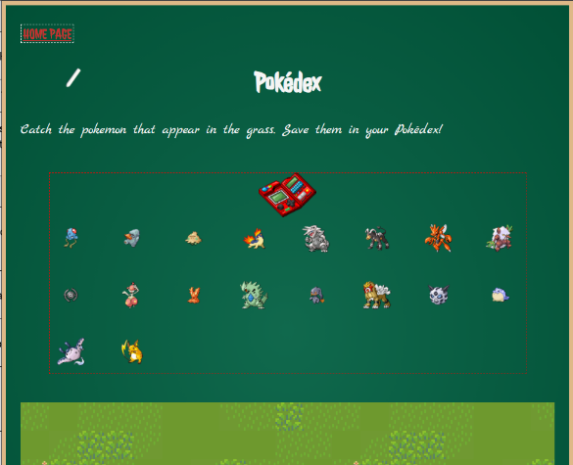The website you develop will be combined with everyone else’s to create a “sitebook” for your own use. The purpose of this assessment is to gauge your ability to write HTML to create a multi-page site, to style that page with CSS, and to make it interactive using JavaScript.

|  |  |  |  |  |  |
| --- | --- | --- | --- | --- | --- |
| **Requirement** | **Points** | **Done? ✅** | **Achievement Standard** | | |
| **Needs Work** | **Satisfactory** | **Excellent** |
| **Files (15)** | | | | | |
| At least **3** separate *pages* (HTML files) which make up your site. | 5 |  | There are less than 3 HTML files. | There are 3 HTML files. | There are more than 3 HTML files. |
| A **home page** file is called index.html | 5 |  | The homepage file is not named index.html. | The homepage is named index.html. | N/A |
| A **stylesheet** which is linkedin the head (<head>) of each page. | 5 |  | The stylesheet is not linked but rather included via a <style> element, or is incorrectly linked. | The stylesheet is a separate file and correctly linked in the header. | N/A |
| **HTML (25)** | | | | | |
| Each *page* contains a *link* (<a>) to another page. | 5 |  | Not all pages contain at least one link. | Each page contains a single link. | There is more than one link on each page (where appropriate) and the links are useful. |
| Each *page* has a title (<title>). | 2 |  | Not all pages have a title. | All pages have a title, but it does not reflect the content of the page. | All pages have a title, and the title reflects the content of the page. |
| Each *page* must use paragraphs (<p>) to contain large fragments of text. | 2 |  | Not all pages contain a paragraph, or the paragraphs are not informative. | Each page contains a single informative paragraph. | Some or all pages contain more than one informative paragraph. |
| At least **one** ordered list (<ol>) on the site. | 2 |  | No ordered list is present on the site, or it is HTML is incorrect. | A page contains an ordered list, but its content does not match the page’s topic. | At lest one page contains an ordered list whose content matches the topic of the page. |
| At least **one** *un*-ordered list (<ul>) on the site. | 2 |  | No un-ordered list is present on the site, or it is HTML is incorrect. | A page contains an un-ordered list, but its content does not match the page’s topic. | At least one page contains an un-ordered list whose content matches the topic of the page. |
| At least **one** table (<table>) on the site. | 5 |  | No table is present on the site. | A page contains a table either the content is not relevant to the page’s topic, *or* the table does not use the proper HTML structure. | At least one page contains a table whose content is relevant to the page and has the correct HTML structure. |
| At least **three** images (<img>) pn the site. | 5 |  | Less than three images are present on the site. | Three or more images are present, but they are not appropriately sized, positioned, or topical. | Three or more images are present and are appropriately sized, positioned, and topical. |
| At least **one** blockquote (<blockquote>) on the site. | 2 |  | No blockquote is present on the site, or it is HTML is incorrect. | A page contains a blockquote, but its content does not match the page’s topic. | At least one page contains a blockquote whose content matches the topic of the page. |
| **CSS (20)** | | | | | |
| At least two **element type** selectors. | 5 |  | Less than two element selectors have been written. | Two element selectors have been written and they effect the styles of the page. | More than two element selectors have been written and they effect the styles of the page. |
| At least two **class** selectors. | 5 |  | Less than two class selectors have been written. | Two class selectors have been written and they effect the styles of the page. | More than two class selectors have been written and they effect the styles of the page. |
| At least one **ID** selector. | 5 |  | No ID selector(s) have been written. | One ID selector has been written and they effect the styles of the page. | More than one ID selector has been written and they effect the styles of the page. |
| At least one ruleset which uses the *color* property. | 1 |  | No ruleset effects the color is present. | One ruleset which effects the color is present. | More than one ruleset which effects the color is present and produces a cohesive design. |
| At least one ruleset which uses the *background-color* property. | 1 |  | No ruleset effects the background-color is present. | One ruleset which effects the background-color is present. | More than one ruleset which effects the background-color is present and produces a cohesive design. |
| At least **five** properties other than *color* or *background-color* have been used. | 3 |  | Less than five different properties matching the criteria have been used on the page to effect styling. | Five different properties matching the criteria are used on the page to effect styling. | More than five properties matching the criteria are used on the page to effect the styling in a cohesive design. |
| **JS (20)** | | | | | |
| At least one interactive or dynamic feature on the site which utilizes JavaScript has been included. Examples:   * Clicking on a paragraph to change its color. * A flying box which you click to increment a counter on the screen. | 20 |  | No JavaScript has been written to effect any page, or the JavaScript written does not produce a visible function on the site. | The written JavaScript creates a single interactive or dynamic feature on the site. | The written JavaScript creates more than one interactive or dynamic feature on the site. |
| **Content (20)** | | | | | |
| The presentation of the site is visually appealing and makes good use of HTML element selection, and CSS styling. | 10 |  | The website does not demonstrate a cohesive design and is not visually appealing. | The website has a very appealing and cohesive design making appropriate use of CSS styling. | N/A |
| The content of the website is both well written and interesting. | 10 |  | Very little content is present on each page, or the content is not engaging. | A moderate amount of engaging content (200 words) is present on the site. | A large amount of engaging content (300 words) is present on the site. |
| **TOTAL** | | / **100** |  |  |  |

**Submission:**Your website will be submitted on **DATE** by copying your files into the following shared drive folder: **PATH TO SHARED DR**